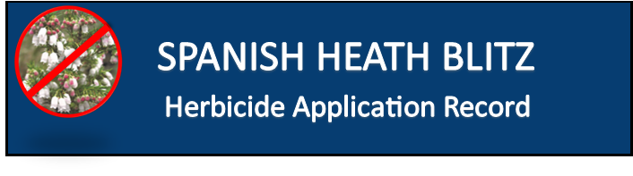
Total number of hours:

Date(s):

Contractor

Name:

Landholder:

Property Address:

Growing conditions Very Good Good Poor Very Poor

Soil conditions Wet Moist Dry Dry Surface

Application data:

 | Date |  | Product Used |  | Rate |  | Total L
1.
2.
3.
4.
5.

